DBMS CAPSTONE PROJECT REPORT
BANK ACCOUNT MANAGEMENT SYSTEM
A DBMS Capstone Project Report submitted in partial fulfillment of the requirements for the award of the degree of
BACHELOR OF TECHNOLOGY
in
ARTIFICIAL INTELLIGENCE AND MACHINE LEARNING
Submitted By
CH. Vinay kumar – 25B11AI225
S. Nikhil– 25B11AIA57
T. Manish– 25B11AIB71
V. Karthik – 25B11AIC38
Under the esteemed guidance of
Mrs. G. L. Narasamba Vanguri,M.Tech.,(Ph.D)
Project Guide
Mr. P. V. V. S. D. Nagendrudu, M.Tech.,(Ph.D)
Project Co-Guide

DEPARTMENT OF ARTIFICIAL INTELLIGENCE AND MACHINE LEARNING

Aditya Nagar, ADB Road, Surampalem, Andhra Pradesh, India
2026 – 2027
Aditya Nagar, ADB Road, Surampalem, Andhra Pradesh, India
DEPARTMENT OF ARTIFICIAL INTELLIGENCE AND MACHINE LEARNING
CERTIFICATE
This is to certify that the DBMS Capstone Project report entitled “Bank Account Management System” is being submitted by vinay (Roll No. 25B11AI225), Nikhil (Roll No. 25B11AIA57), manish (Roll No. 25B11AIB71) and karthik (Roll No. 25B11AIC38) in partial fulfillment of the requirements for the award of the B.Tech. degree in Artificial Intelligence and Machine Learning.
Project Guide  Mrs. G. L. Narasamba, M.Tech.,(Ph.D)  Assistant Professor | Head of the Department  Dr. K. Naga Bhargavi M.Tech, Ph.D.  Associate Professor & HOD
Project Co-Guide
Mr. P. V. V. S. D. Nagendrudu, M.Tech.,(Ph.D)
Assistant Professor
The work documented in this report was carried out as part of the Capstone Project for the course Database Management Systems (2501IT05) during the academic year 2026–2027, and records the database design, implementation, testing and documentation undertaken by the team.

External Examiner
Aditya Nagar, ADB Road, Surampalem, Andhra Pradesh, India
DEPARTMENT OF ARTIFICIAL INTELLIGENCE AND MACHINE LEARNING
DECLARATION
We hereby declare that the DBMS Capstone Project entitled “Bank Account Management System” is a genuine work carried out by us. The database design, SQL implementation, queries and documentation presented in this report are our own work, completed under the guidance of Mrs.G.L.Narasamba,M.Tech,(Ph.D).and co-guidance of Mr. P. V. V. S. D. Nagendrudu,M.Tech,(Ph.D) Department of Artificial Intelligence and Machine Learning, Aditya University, Surampalem.
We further declare that this work has not been submitted, in full or in part, for the award of any degree of this or any other educational institution.
Project Associates
Ch.vinay (25B11AI225)
S.nikhil (25B11AIA57)
T.manish (25B11AIB71)
V.karthik (25B11AIC38)

Date: 5th october,2026
Place: Surampalem
ACKNOWLEDGEMENT
It is with immense pleasure that we express our indebted gratitude to our project guide Mrs. G. L. Narasamba and co-guide Mr. P. V. V. S. D. Nagendrudu, Department of Artificial Intelligence and Machine Learning, who guided us throughout the capstone project. We are thankful for the constant encouragement and valuable suggestions received at every review stage.
We are grateful to Dr. K. Naga Bhargavi, Head of the Department, for inspiring us and for arranging the facilities and resources needed for this project.
We extend our sincere thanks to the Management, Dr. M. Sreenivasa Reddy, Deputy Pro-Chancellor, Dr. M. B. Srinivas, Vice-Chancellor, and Dr. A. Ramesh, Pro Vice-Chancellor (Engineering & Sciences), for providing an excellent academic environment.
Not to forget, we thank the Teaching and Non-Teaching Staff, our parents and our friends, who have directly or indirectly supported us in completing this project on time.
Project Associates
Chikkala Ashwin (25B11AI201)
Padigapati Venkata Karthik Reddy (25B11AI870)
Rachapothu Tulasi Mani Lakshmi Sri (25B11AI999)
Gugulothu Saida (25B11AI376)
ADITYA UNIVERSITY
Surampalem
Department of Artificial Intelligence and Machine Learning
DBMS CAPSTONE PROJECT
PROJECT DOCUMENTATION REPORT
Bank Account Management System
S.No | Student Name | Roll Number
1 | CH. VINAY KUMAR | 25B11AI225
2 | S. NIKHIL | 25B11AIA57
3 | T. MANISH | 25B11AIB71
4 | V. KARTHIK | 25B11AIC38

Guide: Mrs. G. L. Narasamba Vanguri,M.Tech.,(Ph.D)

Co-Guide: Mr. P. V. V. S. D. Nagendrudu, M.Tech.,(Ph.D)

Academic Year: 2026 – 2027
TABLE OF CONTENTS
Certificate i
Declaration ii
Acknowledgement iii
Project Documentation Report iv
1 ABSTRACT vii
List of Figures vi
List of Tables vi
2 INTRODUCTION 1
2.1 Background 1
2.2 Purpose of the Database 1
2.3 Scope of the Project 1
3 PROBLEM STATEMENT 2
4 OBJECTIVES 3
5 TOOLS & TECHNOLOGIES USED 4
6 DATABASE DESIGN 5
6.1 Identified Entities 5
6.2 Entity Attributes 5
6.3 ER Diagram 7
6.4 Relationships & Cardinality 7
6.5 Relational Database Schema 8
6.6 Primary & Foreign Keys 10
6.7 Normalization 11
7 DATABASE IMPLEMENTATION 12
7.1 DDL – Database and Table Creation 12
7.2 Sample Data – DML 13
7.3 Constraints & Data Integrity 14
7.4 DDL, DML & DQL Operations 14
7.5 CRUD Operations & SQL Queries 15
7.6 Data Integrity & Validation 16
7.7 Sample Outputs / Screenshots 17
8 MODULES & FUNCTIONALITIES 20
9 GITHUB REPOSITORY & TEAM RESPONSIBILITIES 21
10 DEMONSTRATION OF THE DATABASE 22
11 ENHANCEMENTS & FUTURE IMPROVEMENTS 23
12 CONCLUSION 24
13 REFERENCES 25
APPENDIX 26
A. Complete SQL Script Files 26
B. Additional Screenshots / Outputs 26
LIST OF FIGURES
Figure 6.1 ER Diagram of the Bank Account Management System 7
Figure 6.2 Primary and Foreign Key Links of the Account Table 10
Figure 7.1 Active savings accounts (Account table, filtered SELECT) 18
Figure 7.2 Accounts grouped by type (aggregate functions, GROUP BY) 18
Figure 7.3 Branches above ₹5,00,000 (JOIN + GROUP BY + HAVING) 19
Figure 7.4 Customers above the average balance (subquery) 19

LIST OF TABLES
Table 5.1 Tools and Technologies Used 4
Table 6.1 Identified Entities 5
Table 6.2 Entity Attributes 7
Table 6.3 Relationships and Cardinality 7
Table 6.4 Relational Schema of the Six Relations 8
Table 6.5 Detailed Schema with Data Types and Constraints 10
Table 6.6 Foreign Keys and the Parent Tables They Reference 10
Table 6.7 Normalisation Steps Applied 11
Table 7.1 Number of Sample Records per Table 13
Table 7.2 Constraints Applied in the Database 14
Table 7.3 SQL Operations and Queries 15
Table 7.4 Output of the JOIN + HAVING Query (Q11) 16
Table 7.5 Output of the Aggregate Query (Q9) 16
Table 7.6 Types of Data Integrity 16
Table 7.7 Validation Checks 17
Table 8.1 Modules and Functionalities 20
Table 9.1 Repository Contents 21
Table 9.2 Team Responsibilities 21
Table 10.1 Demonstration Steps 22
Table A.1 SQL Script Files 26
Table B.1 Screenshot to Database Mapping 26

1. ABSTRACT
The Bank Account Management System is a relational database project designed to manage the core operations of a bank across multiple branches — branches, customers, employees, accounts, transactions and loans. Branch-wise record keeping makes customer information easy to duplicate, balances hard to keep consistent and transactions hard to trace. To overcome this, a normalised relational database was designed from an Entity–Relationship model and implemented with six related tables: Branch, Customer, Employee, Account, TransactionRecord and Loan.
The tables are connected through primary and foreign keys and protected by NOT NULL, UNIQUE, CHECK and DEFAULT constraints, so that every fact is stored once and linked correctly. The database was populated with 97 representative sample records — 5 branches, 10 customers, 12 employees, 15 accounts, 5 loans and 50 transactions — and tested with SQL queries covering selection and filtering, balance updates with transaction logging, joins, aggregate functions, GROUP BY / HAVING and subqueries.
The query outputs, executed on PostgreSQL, show the database working end to end. The 15 accounts are split into 3 Fixed Deposit, 8 Savings and 4 Current accounts holding ₹29,86,701.50 in total, and two branches — Hyderabad Corp and Vizag Branch — hold more than ₹5,00,000 each, all produced by SQL aggregate queries.
Keywords: Bank Account Management, DBMS, SQL, PostgreSQL, ER Diagram, Normalization, Primary Key, Foreign Key, Data Integrity.

2. INTRODUCTION

2.1 Background
A bank continuously handles large amounts of structured information: who its customers are, which branch serves them, which accounts they hold, what deposits and withdrawals take place, which loans have been sanctioned and which employees run each branch. When this information is kept in separate branch-wise records, the same customer is recorded many times, details do not match between branches, and tracing a single transaction becomes slow.
A relational database solves this by keeping each kind of information in its own table and connecting the tables with keys. In this project, the banking domain is represented using six related tables: Branch, Customer, Employee, Account, Loan and TransactionRecord. Keys and constraints reduce duplication and protect data integrity, and SQL queries are used to retrieve, update, aggregate and analyse the stored information.

2.2 Purpose of the Database
The database provides a centralised structure for managing branch details, customer identity and contact information, employee details, account balances and statuses, loan information and account transaction history. It supports banking staff and administrators who need to retrieve customer and account information, maintain balances, record transactions and monitor loans, and it allows them to generate summary information such as total funds per branch or the number of accounts per account type. The relationships between the tables allow related information to be accessed through SQL joins and subqueries instead of maintaining disconnected records.

2.3 Scope of the Project
Within scope
- Design of the ER model, relational schema and normalisation up to 3NF.
- Implementation of the six-table banking database with all keys and constraints.
- Sample data for all six tables, balance updates with transaction logging, and SQL operations (DDL, DML, DQL, CRUD), joins, aggregates and subqueries.
- Data-integrity validation queries and screenshots of the query outputs.
Outside the current scope
- A front-end application, user login and role-based access, automated EMI calculation, audit logging, triggers and stored procedures (listed under future improvements).

3. PROBLEM STATEMENT
Traditional branch-wise record keeping in a bank leads to several problems:
- Customer details are repeated in every branch, so the same customer is recorded more than once.
- Account, loan and employee records become inconsistent between branches.
- Transactions are difficult to track, and balances can drift away from the transaction history.
- There is no reliable link between a customer, the accounts and loans they hold, the branch that serves them and the transactions on each account.
The problem statement of this project is to design and implement a normalised relational database that centralises branch, customer, employee, account, loan and transaction information into a single database, and provides structured data management, referential integrity, validation and SQL-based reporting for efficient banking operations.

4. OBJECTIVES
The project has the following objectives:
- Design — a relational schema containing six related banking entities.
- Protect — data integrity with primary keys, foreign keys, NOT NULL, UNIQUE, CHECK and DEFAULT constraints.
- Populate — the database with representative branch, customer, employee, account, loan and transaction records.
- Demonstrate — SQL retrieval, updates, joins, aggregate functions, GROUP BY / HAVING and subqueries.
- Document — the database design, implementation, sample data, queries and team responsibilities.

5. TOOLS & TECHNOLOGIES USED

Category | Tool / Technology Used
Database Server | PostgreSQL (relational database management system)
Query Language | SQL — DDL, DML and DQL
Query / Admin Tool | SQL client / notebook (query execution and output screenshots)
Design Technique | Entity–Relationship (ER) modelling and normalisation (1NF, 2NF, 3NF)
Front-end | Not applicable — the database is demonstrated through SQL queries and their outputs
Version Control | Git and GitHub — project repository
Documentation | Microsoft Word (project report)
Table 5.1: Tools and Technologies Used

6. DATABASE DESIGN

6.1 Identified Entities
Six entities were identified from the banking workflow. Each entity became one table in the database.
S.No | Entity Name | Description
1 | Branch | Bank branch identification, location, IFSC code, manager name and creation date.
2 | Customer | Customer identity, contact details, KYC-related identifiers (Aadhaar and PAN), address and creation date.
3 | Employee | Employee details with branch assignment, designation, qualification, salary and contact information.
4 | Account | Customer bank accounts with branch, account type, balance, opening date and status.
5 | TransactionRecord | Deposits, withdrawals and transfers with amount, date, mode and description for each account.
6 | Loan | Customer loans with branch, loan type, amounts, interest rate, duration, EMI, status and sanction date.
Table 6.1: Identified Entities

6.2 Entity Attributes
The six entities have a total of 56 attributes. The table below lists every attribute with its data type, key role and attribute type (PK = primary key, FK = foreign key).
Entity | Attribute | Data Type | Key | Attribute Type
Branch | BranchID | INTEGER | PK | Simple
Branch | BranchName | VARCHAR(50) | — | Simple
Branch | IFSCCode | VARCHAR(11) | — | Simple
Branch | City | VARCHAR(50) | — | Simple
Branch | State | VARCHAR(50) | — | Simple
Branch | ManagerName | VARCHAR(50) | — | Simple
Branch | CreatedAt | DATE | — | Derived / Default
Customer | CustomerID | INTEGER | PK | Simple
Customer | FirstName | VARCHAR(30) | — | Simple
Customer | MiddleName | VARCHAR(30) | — | Simple
Customer | LastName | VARCHAR(30) | — | Simple
Customer | DOB | DATE | — | Simple
Customer | Gender | VARCHAR(10) | — | Simple
Customer | AadhaarNo | VARCHAR(12) | — | Simple
Customer | PANNo | VARCHAR(10) | — | Simple
Customer | Email | VARCHAR(100) | — | Simple
Customer | Phone | VARCHAR(12) | — | Simple
Customer | Address | VARCHAR(100) | — | Simple
Customer | CreatedAt | DATE | — | Derived / Default
Employee | EmployeeID | INTEGER | PK | Simple
Employee | BranchID | INTEGER | FK | Simple
Employee | FirstName | VARCHAR(30) | — | Simple
Employee | MiddleName | VARCHAR(30) | — | Simple
Employee | LastName | VARCHAR(30) | — | Simple
Employee | Designation | VARCHAR(50) | — | Simple
Employee | Qualifications | TEXT | — | Simple
Employee | Salary | DECIMAL(12,2) | — | Simple
Employee | Phone | VARCHAR(12) | — | Simple
Employee | Email | VARCHAR(100) | — | Simple
Employee | HireDate | DATE | — | Simple
Account | AccountNumber | VARCHAR(20) | PK | Simple
Account | CustomerID | INTEGER | FK | Simple
Account | BranchID | INTEGER | FK | Simple
Account | AccountType | VARCHAR(20) | — | Simple
Account | Balance | DECIMAL(15,2) | — | Simple
Account | OpenDate | DATE | — | Simple
Account | Status | VARCHAR(15) | — | Simple
TransactionRecord | TransactionID | INTEGER | PK | Simple
TransactionRecord | AccountNumber | VARCHAR(20) | FK | Simple
TransactionRecord | TransactionType | VARCHAR(15) | — | Simple
TransactionRecord | Amount | DECIMAL(15,2) | — | Simple
TransactionRecord | TransactionDate | DATE | — | Derived / Default
TransactionRecord | Mode | VARCHAR(20) | — | Simple
TransactionRecord | Description | VARCHAR(255) | — | Simple
Loan | LoanID | INTEGER | PK | Simple
Loan | CustomerID | INTEGER | FK | Simple
Loan | BranchID | INTEGER | FK | Simple
Loan | LoanType | VARCHAR(50) | — | Simple
Loan | LoanAmount | DECIMAL(15,2) | — | Simple
Loan | PrincipalAmount | DECIMAL(15,2) | — | Simple
Loan | InterestRate | DECIMAL(5,2) | — | Simple
Loan | StartDate | DATE | — | Simple
Loan | DurationMonths | INTEGER | — | Simple
Loan | EmiAmount | DECIMAL(10,2) | — | Simple
Loan | Status | VARCHAR(20) | — | Simple

6.3 ER Diagram
The ER diagram shows the entities, their attributes and the relationships between them. Rectangles are entities, ellipses are attributes, diamonds are relationships, 1 / N show cardinality, and underlined names are primary keys.
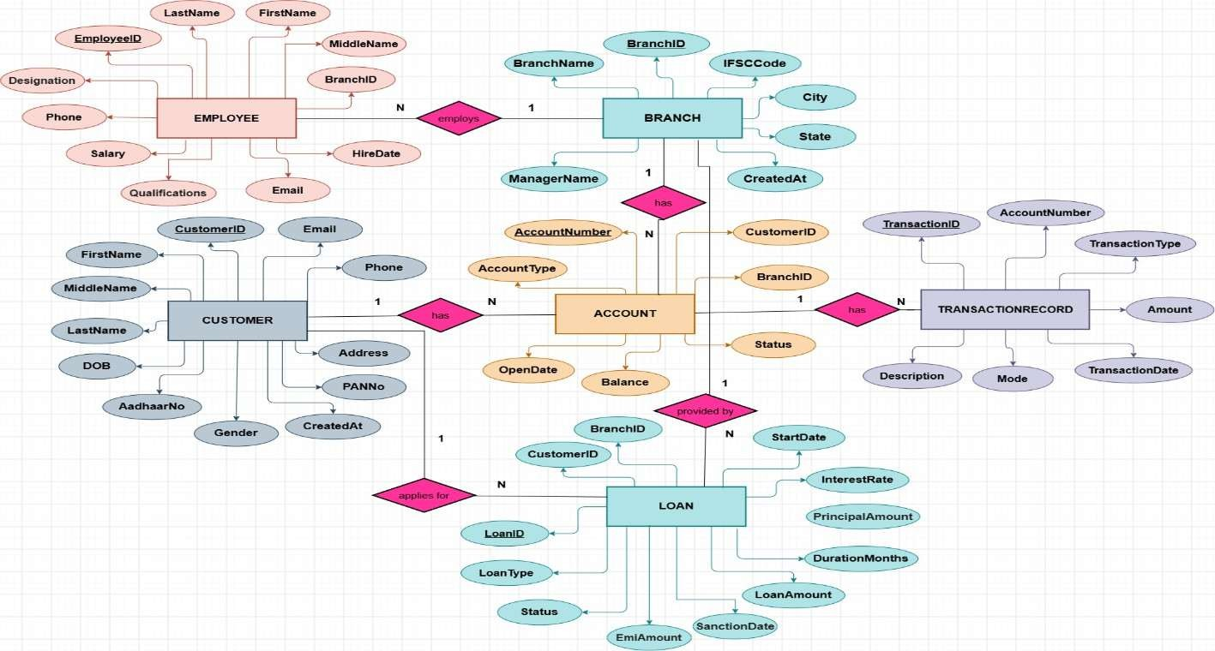
Figure 6.1: ER Diagram of the Bank Account Management System

Reading the diagram: a Branch employs many Employees, has many Accounts and handles many Loans; a Customer owns many Accounts and takes many Loans; and each Account has many Transaction Records.

6.4 Relationships & Cardinality
Entity 1 | Relationship | Entity 2 | Cardinality | Implemented By
Branch | employs | Employee | 1 : N | Employee.BranchID (FK)
Branch | has | Account | 1 : N | Account.BranchID (FK)
Branch | handles | Loan | 1 : N | Loan.BranchID (FK)
Customer | owns | Account | 1 : N | Account.CustomerID (FK)
Customer | takes | Loan | 1 : N | Loan.CustomerID (FK)
Account | has | TransactionRecord | 1 : N | TransactionRecord.AccountNumber (FK)
Table 6.4: Relationships and Cardinality
Notes. In the ER diagram the relationships are named “employs”, “has”, “provided by” and “applies for”. All relationships in this design are one-to-many, so each is implemented by placing a foreign key on the N side. There is no many-to-many relationship, so no separate junction table is required.

6.5 Relational Database Schema
Mapping rule: each entity became one relation, and each 1 : N relationship placed a foreign key on the N side.
Relation | Relational Schema | Keys
Branch | Branch (BranchID, BranchName, IFSCCode, City, State, ManagerName, CreatedAt) | PK: BranchID
Customer | Customer (CustomerID, FirstName, MiddleName, LastName, DOB, Gender, AadhaarNo, PANNo, Email, Phone, Address, CreatedAt) | PK: CustomerID
Employee | Employee (EmployeeID, BranchID, FirstName, MiddleName, LastName, Designation, Qualifications, Salary, Phone, Email, HireDate) | PK: EmployeeID FK: BranchID
Account | Account (AccountNumber, CustomerID, BranchID, AccountType, Balance, OpenDate, Status) | PK: AccountNumber FK: CustomerID, BranchID
TransactionRecord | TransactionRecord (TransactionID, AccountNumber, TransactionType, Amount, TransactionDate, Mode, Description) | PK: TransactionID FK: AccountNumber
Loan | Loan (LoanID, CustomerID, BranchID, LoanType, LoanAmount, PrincipalAmount, InterestRate, StartDate, DurationMonths, EmiAmount, Status, SanctionDate) | PK: LoanID FK: CustomerID, BranchID
Table 6.5: Relational Schema of the Six Relations
The detailed schema with data types and constraints for every column is given below.
Table | Column | Data Type | PK/FK | Constraints
Branch | BranchID | INTEGER | PK | PRIMARY KEY
Branch | BranchName | VARCHAR(50) | — | NOT NULL
Branch | IFSCCode | VARCHAR(11) | — | NOT NULL, UNIQUE, CHECK length = 11
Branch | City | VARCHAR(50) | — | NOT NULL
Branch | State | VARCHAR(50) | — | NOT NULL
Branch | ManagerName | VARCHAR(50) | — | NOT NULL
Branch | CreatedAt | DATE | — | DEFAULT CURRENT_DATE
Customer | CustomerID | INTEGER | PK | PRIMARY KEY
Customer | FirstName | VARCHAR(30) | — | NOT NULL
Customer | MiddleName | VARCHAR(30) | — | NULL allowed
Customer | LastName | VARCHAR(30) | — | NOT NULL
Customer | DOB | DATE | — | NOT NULL
Customer | Gender | VARCHAR(10) | — | CHECK (Male, Female, Other)
Customer | AadhaarNo | VARCHAR(12) | — | NOT NULL, UNIQUE, CHECK length = 12
Customer | PANNo | VARCHAR(10) | — | NOT NULL, UNIQUE, CHECK length = 10
Customer | Email | VARCHAR(100) | — | NOT NULL, UNIQUE
Customer | Phone | VARCHAR(12) | — | NOT NULL
Customer | Address | VARCHAR(100) | — | NOT NULL
Customer | CreatedAt | DATE | — | DEFAULT CURRENT_DATE
Employee | EmployeeID | INTEGER | PK | PRIMARY KEY
Employee | BranchID | INTEGER | FK | NOT NULL, FK → Branch
Employee | FirstName | VARCHAR(30) | — | NOT NULL
Employee | MiddleName | VARCHAR(30) | — | NULL allowed
Employee | LastName | VARCHAR(30) | — | NOT NULL
Employee | Designation | VARCHAR(50) | — | NOT NULL
Employee | Qualifications | TEXT | — | NULL allowed
Employee | Salary | DECIMAL(12,2) | — | NOT NULL, CHECK >= 0
Employee | Phone | VARCHAR(12) | — | NOT NULL
Employee | Email | VARCHAR(100) | — | NOT NULL, UNIQUE
Employee | HireDate | DATE | — | NOT NULL
Account | AccountNumber | VARCHAR(20) | PK | PRIMARY KEY
Account | CustomerID | INTEGER | FK | NOT NULL, FK → Customer
Account | BranchID | INTEGER | FK | NOT NULL, FK → Branch
Account | AccountType | VARCHAR(20) | — | NOT NULL, CHECK (Savings, Current, Fixed Deposit)
Account | Balance | DECIMAL(15,2) | — | NOT NULL, DEFAULT 0.00, CHECK >= 0
Account | OpenDate | DATE | — | NOT NULL
Account | Status | VARCHAR(15) | — | NOT NULL, DEFAULT 'Active', CHECK (Active, Inactive, Frozen, Closed)
TransactionRecord | TransactionID | INTEGER | PK | PRIMARY KEY
TransactionRecord | AccountNumber | VARCHAR(20) | FK | NOT NULL, FK → Account
TransactionRecord | TransactionType | VARCHAR(15) | — | NOT NULL, CHECK (Deposit, Withdrawal, Transfer)
TransactionRecord | Amount | DECIMAL(15,2) | — | NOT NULL, CHECK > 0
TransactionRecord | TransactionDate | DATE | — | DEFAULT CURRENT_DATE
TransactionRecord | Mode | VARCHAR(20) | — | NOT NULL, CHECK (Online, ATM, Branch, UPI, Net Banking)
TransactionRecord | Description | VARCHAR(255) | — | NULL allowed
Loan | LoanID | INTEGER | PK | PRIMARY KEY
Loan | CustomerID | INTEGER | FK | NOT NULL, FK → Customer
Loan | BranchID | INTEGER | FK | NOT NULL, FK → Branch
Loan | LoanType | VARCHAR(50) | — | NOT NULL, CHECK (Home, Car, Personal, Education, Business)
Loan | LoanAmount | DECIMAL(15,2) | — | NOT NULL, CHECK > 0
Loan | PrincipalAmount | DECIMAL(15,2) | — | CHECK > 0, NULL allowed
Loan | InterestRate | DECIMAL(5,2) | — | NOT NULL, CHECK 0 to 100
Loan | StartDate | DATE | — | NOT NULL
Loan | DurationMonths | INTEGER | — | NOT NULL, CHECK > 0
Loan | EmiAmount | DECIMAL(10,2) | — | CHECK >= 0
Loan | Status | VARCHAR(20) | — | NOT NULL, DEFAULT 'Pending', CHECK (Approved, Pending, Closed, Rejected, Active, Default)
Loan | SanctionDate | DATE | — | NULL allowed
Table 6.5: Detailed Schema with Data Types and Constraints

6.6 Primary & Foreign Keys
Every table has a single-column primary key that is never NULL or repeated (entity integrity). Foreign keys accept only values that exist in the parent table (referential integrity), so an account, loan or transaction can never point to a missing customer, branch or account.
Child Table | Foreign Key | References
Employee | BranchID | Branch (BranchID)
Account | CustomerID | Customer (CustomerID)
Account | BranchID | Branch (BranchID)
TransactionRecord | AccountNumber | Account (AccountNumber)
Loan | CustomerID | Customer (CustomerID)
Loan | BranchID | Branch (BranchID)
Table 6.6: Foreign Keys and the Parent Tables They Reference
The figure below shows how the Account table links a Customer and a Branch through its two foreign keys.
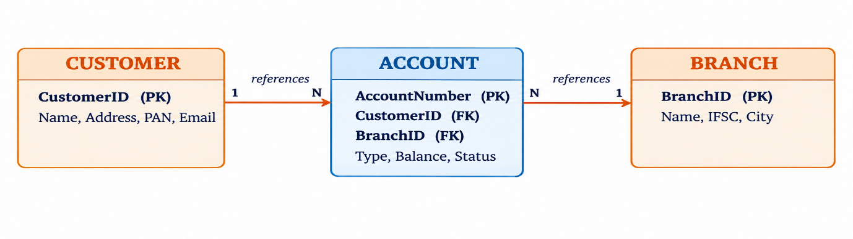
Figure 6.2: Primary and Foreign Key Links of the Account Table

6.7 Normalization
Normalisation removes redundancy and prevents insertion, update and deletion anomalies. The design moves from an unnormalised form (UNF) to Third Normal Form (3NF).
Stage | Rule | How it was applied in the banking database
UNF | All data kept in one large record. | One record holds branch, customer, employee, account, loan and transaction details together, repeated for every transaction.
1NF | Every attribute is atomic; no repeating groups. | Customer names are split into FirstName, MiddleName and LastName, the address is stored as one value, and each transaction or loan becomes a separate row.
2NF | No partial dependency on a key. | Each entity has its own single-column primary key, so every non-key column depends on the whole key; customer facts are not repeated in accounts, loans or transactions.
3NF | No transitive dependency. | AccountNumber → BranchID → BranchName is a transitive chain, so Branch is a separate table and Account keeps only BranchID as a foreign key.
Table 6.7: Normalisation Steps Applied

7. DATABASE IMPLEMENTATION

7.1 DDL – Database and Table Creation
The tables are created in foreign-key dependency order (Branch → Customer → Employee → Account → TransactionRecord → Loan) so that every parent table exists before its child tables. Existing tables are dropped first, child tables before parents, so the script can be re-run safely.
-- Bank Account Management System : table definitions (SQL)
-- Drop tables if they exist (child tables first)
DROP TABLE IF EXISTS TransactionRecord;
DROP TABLE IF EXISTS Loan;
DROP TABLE IF EXISTS Account;
DROP TABLE IF EXISTS Employee;
DROP TABLE IF EXISTS Customer;
DROP TABLE IF EXISTS Branch;

-- 1. BRANCH
CREATE TABLE Branch (
BranchID INTEGER PRIMARY KEY,
BranchName VARCHAR(50) NOT NULL,
IFSCCode VARCHAR(11) NOT NULL UNIQUE,
City VARCHAR(50) NOT NULL,
State VARCHAR(50) NOT NULL,
ManagerName VARCHAR(50) NOT NULL,
CreatedAt DATE DEFAULT CURRENT_DATE,
CONSTRAINT chk_ifsc_len CHECK (LENGTH(IFSCCode) = 11)
);

-- 2. CUSTOMER
CREATE TABLE Customer (
CustomerID INTEGER PRIMARY KEY,
FirstName VARCHAR(30) NOT NULL,
MiddleName VARCHAR(30),
LastName VARCHAR(30) NOT NULL,
DOB DATE NOT NULL,
Gender VARCHAR(10) CHECK (Gender IN ('Male','Female','Other')),
AadhaarNo VARCHAR(12) NOT NULL UNIQUE,
PANNo VARCHAR(10) NOT NULL UNIQUE,
Email VARCHAR(100) NOT NULL UNIQUE,
Phone VARCHAR(12) NOT NULL,
Address VARCHAR(100) NOT NULL,
CreatedAt DATE DEFAULT CURRENT_DATE,
CONSTRAINT chk_aadhaar CHECK (LENGTH(AadhaarNo) = 12),
CONSTRAINT chk_pan CHECK (LENGTH(PANNo) = 10)
);

-- 3. EMPLOYEE
CREATE TABLE Employee (
EmployeeID INTEGER PRIMARY KEY,
BranchID INTEGER NOT NULL,
FirstName VARCHAR(30) NOT NULL,
MiddleName VARCHAR(30),
LastName VARCHAR(30) NOT NULL,
Designation VARCHAR(50) NOT NULL,
Qualifications TEXT,
Salary DECIMAL(12,2) NOT NULL CHECK (Salary >= 0),
Phone VARCHAR(12) NOT NULL,
Email VARCHAR(100) NOT NULL UNIQUE,
HireDate DATE NOT NULL,
FOREIGN KEY (BranchID) REFERENCES Branch(BranchID)
);

-- 4. ACCOUNT
CREATE TABLE Account (
AccountNumber VARCHAR(20) PRIMARY KEY,
CustomerID INTEGER NOT NULL,
BranchID INTEGER NOT NULL,
AccountType VARCHAR(20) NOT NULL
CHECK (AccountType IN ('Savings','Current','Fixed Deposit')),
Balance DECIMAL(15,2) NOT NULL DEFAULT 0.00 CHECK (Balance >= 0),
OpenDate DATE NOT NULL,
Status VARCHAR(15) NOT NULL DEFAULT 'Active'
CHECK (Status IN ('Active','Inactive','Frozen','Closed')),
FOREIGN KEY (CustomerID) REFERENCES Customer(CustomerID),
FOREIGN KEY (BranchID) REFERENCES Branch(BranchID)
);

-- 5. TRANSACTIONRECORD
CREATE TABLE TransactionRecord (
TransactionID INTEGER PRIMARY KEY,
AccountNumber VARCHAR(20) NOT NULL,
TransactionType VARCHAR(15) NOT NULL
CHECK (TransactionType IN ('Deposit','Withdrawal','Transfer')),
Amount DECIMAL(15,2) NOT NULL CHECK (Amount > 0),
TransactionDate DATE DEFAULT CURRENT_DATE,
Mode VARCHAR(20) NOT NULL
CHECK (Mode IN ('Online','ATM','Branch','UPI','Net Banking')),
Description VARCHAR(255),
FOREIGN KEY (AccountNumber) REFERENCES Account(AccountNumber)
);

-- 6. LOAN
CREATE TABLE Loan (
LoanID INTEGER PRIMARY KEY,
CustomerID INTEGER NOT NULL,
BranchID INTEGER NOT NULL,
LoanType VARCHAR(50) NOT NULL
CHECK (LoanType IN ('Home','Car','Personal','Education','Business')),
LoanAmount DECIMAL(15,2) NOT NULL CHECK (LoanAmount > 0),
PrincipalAmount DECIMAL(15,2) CHECK (PrincipalAmount > 0),
InterestRate DECIMAL(5,2) NOT NULL
CHECK (InterestRate >= 0 AND InterestRate <= 100),
StartDate DATE NOT NULL,
DurationMonths INTEGER NOT NULL CHECK (DurationMonths > 0),
EmiAmount DECIMAL(10,2) CHECK (EmiAmount >= 0),
Status VARCHAR(20) NOT NULL DEFAULT 'Pending'
CHECK (Status IN ('Approved','Pending','Closed','Rejected','Active','Default')),
SanctionDate DATE,
FOREIGN KEY (CustomerID) REFERENCES Customer(CustomerID),
FOREIGN KEY (BranchID) REFERENCES Branch(BranchID)
);

7.2 Sample Data – DML
Each table was filled with representative records. Data is inserted in the same dependency order used for table creation.
Table | No. of Records | Source
Branch | 05 | dml.sql — Branch seed records
Customer | 10 | dml.sql — Customer seed records
Employee | 12 | dml.sql — Employee seed records
Account | 15 | dml.sql — Account seed records
TransactionRecord | 50 | dml.sql — Transaction seed records
Loan | 05 | dml.sql — Loan seed records
Total | 97
Table 7.1: Number of Sample Records per Table

7.3 Constraints & Data Integrity
Constraint | Applied On | Purpose | Example
PRIMARY KEY | All six tables | Uniquely identifies each row; no NULL or repeated key. | BranchID INTEGER PRIMARY KEY
FOREIGN KEY | Employee, Account, TransactionRecord, Loan | Links child rows to a valid parent row. | Account.CustomerID → Customer
NOT NULL | Names, identifiers, contact details, dates, amounts, foreign keys | Required fields cannot be left empty. | FirstName NOT NULL
UNIQUE | Branch.IFSCCode; Customer.AadhaarNo, PANNo, Email; Employee.Email | No two records share the same identifier or contact value. | AadhaarNo UNIQUE
CHECK | Gender, AccountType, Balance, Status, TransactionType, Mode, loan values, code lengths | Accepts only valid values and ranges. | Balance CHECK (Balance >= 0)
DEFAULT | CreatedAt, Account.Balance and Status, TransactionDate, Loan.Status | Supplies a value when none is given. | Status DEFAULT 'Active'
Table 7.2: Constraints Applied in the Database

7.4 DDL, DML & DQL Operations
SQL statements are grouped by purpose. DDL defines and modifies the structure, DML adds, changes and removes the data, and DQL retrieves it. The statements below are illustrative examples on the banking tables.

DDL – Data Definition Language
CREATE TABLE Branch_Archive AS SELECT * FROM Branch;
ALTER TABLE Employee ADD Department VARCHAR(30);
TRUNCATE TABLE TransactionRecord; -- removes all rows, keeps the structure
DROP TABLE TransactionRecord; -- removes the table completely

DML – Data Manipulation Language
INSERT INTO Customer (CustomerID, FirstName, LastName, DOB, AadhaarNo,
PANNo, Email, Phone, Address)
VALUES (11, 'Ravi', 'Teja', '2000-03-15', '123456789012',
'ABCDE1234F', 'ravi.teja@example.com', '9876543210', 'Kakinada');
UPDATE Account SET Status = 'Frozen' WHERE AccountNumber = '10001';
DELETE FROM Customer WHERE CustomerID = 11;

DQL – Data Query Language
SELECT * FROM Account WHERE AccountType = 'Savings';
SELECT * FROM Customer ORDER BY LastName ASC;
SELECT BranchID, COUNT(*) AS Total_Accounts FROM Account
GROUP BY BranchID HAVING COUNT(*) > 2;
SELECT DISTINCT AccountType FROM Account;

Clause order: SELECT → FROM → WHERE → GROUP BY → HAVING → ORDER BY → LIMIT.

7.5 CRUD Operations & SQL Queries
The four basic CRUD operations were performed on the Customer table:
-- C : CREATE
INSERT INTO Customer (CustomerID, FirstName, LastName, DOB, AadhaarNo,
PANNo, Email, Phone, Address)
VALUES (12, 'Kiran', 'Kumar', '1999-08-20', '210987654321',
'PQRST5678K', 'kiran.k@example.com', '9812345670', 'Vizag');
-- R : READ
SELECT c.FirstName, c.LastName, a.AccountNumber, a.Balance
FROM Customer c JOIN Account a ON c.CustomerID = a.CustomerID;
-- U : UPDATE
UPDATE Customer SET Phone = '9898989898' WHERE CustomerID = 12;
-- D : DELETE
DELETE FROM Customer WHERE CustomerID = 12;

The complete set of queries used for reports and analysis is listed below and saved in queries.sql.
S.No | Operation / Query | Purpose | Reference
1 | Basic SELECT — all customers | Retrieve customer records. | queries.sql Q1
2 | Filtered SELECT — active savings accounts | Find active savings accounts ordered by balance. | queries.sql Q2
3 | LIKE filtering | Search customers by name or email domain. | queries.sql Q3
4 | Balance lookup | Check the balance of account 10001. | queries.sql Q4
5 | UPDATE + INSERT | Deposit ₹5,000 into account 10001 and record the transaction. | queries.sql Q5
6 | UPDATE + INSERT | Withdraw ₹1,000 when sufficient balance exists and record the transaction. | queries.sql Q6
7 | Transaction history | Display account transaction history in descending date order. | queries.sql Q7
8 | SUM aggregate | Calculate total funds across all accounts. | queries.sql Q8
9 | GROUP BY + aggregates | Calculate account count, average balance and total balance by account type. | queries.sql Q9
10 | GROUP BY + aggregates | Calculate active loan count, total sanctioned amount and average interest rate by loan type. | queries.sql Q10
11 | JOIN + GROUP BY + HAVING | Find branches whose total account balance exceeds ₹5,00,000. | queries.sql Q11
12 | JOIN + GROUP BY + HAVING | Find customers holding more than one account. | queries.sql Q12
13 | Subquery | Find customers whose total account balance exceeds the average account balance. | queries.sql Q13
14 | Subquery + ORDER BY + LIMIT | List transactions for the highest-balance account. | queries.sql Q14
Table 7.3: SQL Operations and Queries
-- Q2 Retrieve all active savings accounts
SELECT AccountNumber, CustomerID, Balance, OpenDate
FROM Account
WHERE AccountType = 'Savings' AND Status = 'Active'
ORDER BY Balance DESC;

-- Q9 Average account balance grouped by account type
SELECT AccountType, COUNT(*) AS AccountCount,
AVG(Balance) AS AverageBalance, SUM(Balance) AS TotalTypeBalance
FROM Account
GROUP BY AccountType;

-- Q11 Branches where total account balance exceeds Rs. 500,000
SELECT b.BranchName, SUM(a.Balance) AS TotalBalance
FROM Branch b
JOIN Account a ON b.BranchID = a.BranchID
GROUP BY b.BranchID, b.BranchName
HAVING SUM(a.Balance) > 500000;

-- Q13 Customers whose total balance exceeds the average account balance
SELECT CustomerID, FirstName, LastName, Email
FROM Customer
WHERE CustomerID IN (
SELECT CustomerID
FROM Account
GROUP BY CustomerID
HAVING SUM(Balance) > (SELECT AVG(Balance) FROM Account)
);

Output of Q11 (branches with total balance above ₹5,00,000):
BranchName | TotalBalance
Hyderabad Corp | ₹15,63,000.00
Vizag Branch | ₹5,73,500.00
Table 7.4: Output of the JOIN + HAVING Query (Q11)
Output of Q9 (accounts grouped by type):
AccountType | AccountCount | AverageBalance | TotalTypeBalance
Fixed Deposit | 3 | ₹5,50,000.00 | ₹16,50,000.00
Savings | 8 | ₹63,337.69 | ₹5,06,701.50
Current | 4 | ₹2,07,500.00 | ₹8,30,000.00
Table 7.5: Output of the Aggregate Query (Q9)

7.6 Data Integrity & Validation
Four types of integrity are enforced in the database.
Integrity Type | Meaning | How the database enforces it
Entity integrity | Every table has a primary key; no key value is NULL or repeated. | PRIMARY KEY on all six tables.
Referential integrity | Foreign keys accept only existing parent values. | FOREIGN KEY constraints: no account, loan or transaction can point to a missing customer, branch or account.
Domain integrity | Columns accept only valid types and values. | DATE, INTEGER, VARCHAR and DECIMAL types; CHECK on Gender, AccountType, Status, Mode and amounts.
User-defined integrity | Business rules of the bank. | Aadhaar, PAN and Email are UNIQUE; IFSC, Aadhaar and PAN lengths are checked; balances cannot be negative; a withdrawal is made only when the balance is sufficient.
Table 7.6: Types of Data Integrity
After data entry, the following validation queries can be run. Each query is written to return rows only when a problem exists.
-- 1. Duplicate account numbers
SELECT AccountNumber, COUNT(*) FROM Account GROUP BY AccountNumber HAVING COUNT(*) > 1;
-- 2. Orphan transactions (account missing)
SELECT * FROM TransactionRecord WHERE AccountNumber NOT IN (SELECT AccountNumber FROM Account);
-- 3. Required customer fields missing
SELECT * FROM Customer WHERE FirstName IS NULL OR LastName IS NULL
OR AadhaarNo IS NULL OR PANNo IS NULL;
-- 4. Negative account balances
SELECT * FROM Account WHERE Balance < 0;

No. | Validation Check | Expected Rows | Enforced By
1 | No duplicate account numbers | 0 | PRIMARY KEY on Account
2 | No orphan transactions | 0 | FOREIGN KEY on TransactionRecord
3 | Required customer fields present | 0 | NOT NULL on Customer
4 | No negative balances | 0 | CHECK (Balance >= 0) on Account
Table 7.7: Validation Checks
Because each of these rules is enforced by a constraint, a validation query returns no rows when the data is correct.

7.7 Sample Outputs / Screenshots
The screenshots below show the queries of Section 7.5 executed in a PostgreSQL SQL client against the banking database. Each screenshot shows the query and the result table it produced.

Active Savings Accounts
Lists the eight active savings accounts in descending order of balance, with account number, customer ID, balance and opening date (Q2). Account 10006 holds the highest balance, ₹1,45,000.00.
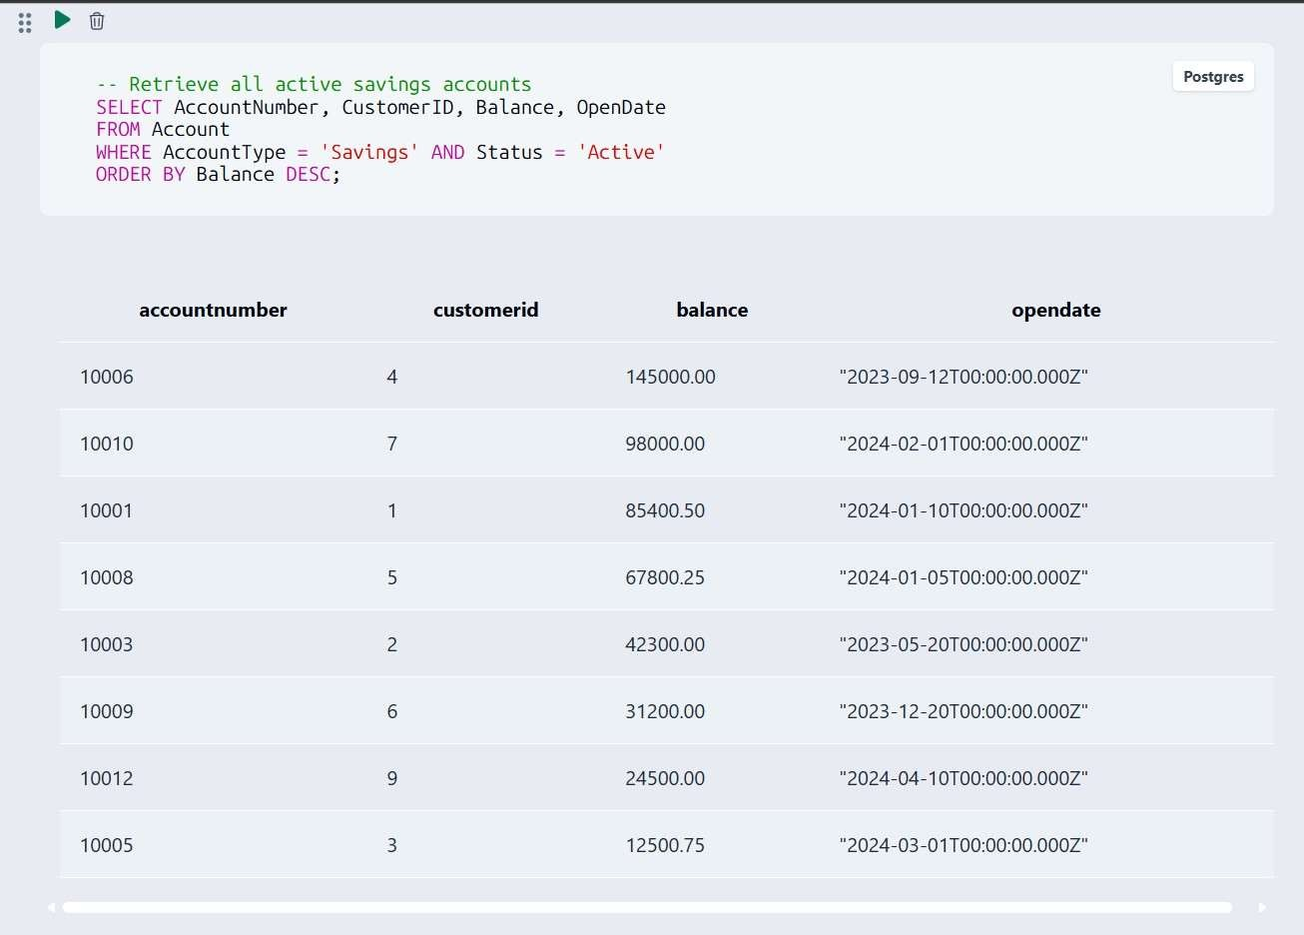
Figure 7.1: Active savings accounts (Account table, filtered SELECT)

Accounts Grouped by Type
Shows the number of accounts, the average balance and the total balance for each account type (Q9) — Fixed Deposit, Savings and Current, 15 accounts in all.
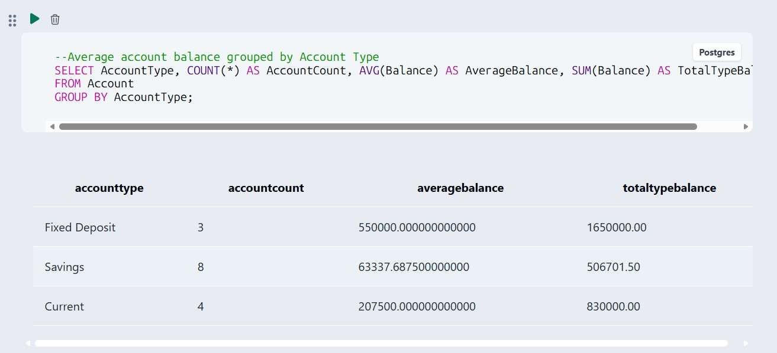
Figure 7.2: Accounts grouped by type (aggregate functions, GROUP BY)

Branch-wise Balances
Joins Branch and Account, groups by branch and keeps only branches whose total balance exceeds ₹5,00,000 (Q11): Hyderabad Corp and Vizag Branch.
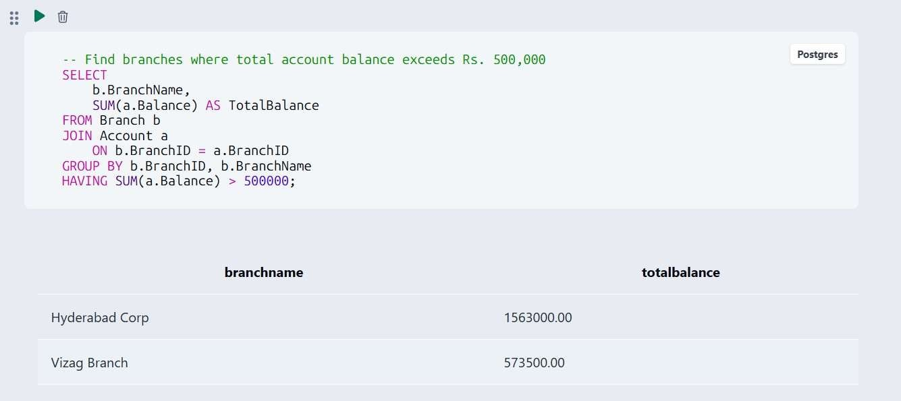
Figure 7.3: Branches above ₹5,00,000 (JOIN + GROUP BY + HAVING)

Customers Above the Average Balance
A subquery finds the customers whose total account balance is higher than the average account balance (Q13); four customers (IDs 1, 2, 4 and 10) qualify.
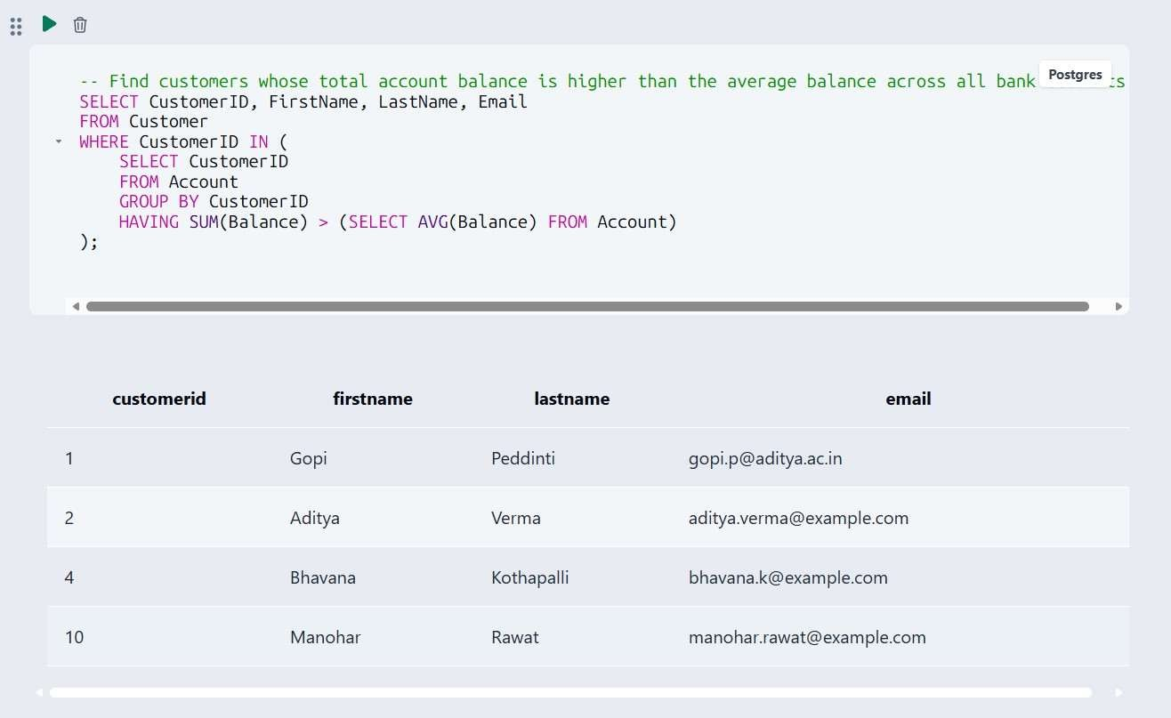
Figure 7.4: Customers above the average balance (subquery)

8. MODULES & FUNCTIONALITIES
The system is organised into six modules, one for each major entity. Every module reads from or writes to the corresponding tables of the database through the SQL operations described in Section 7.5.
S.No | Module Name | Functionality | Main Tables
1 | Branch Management | Stores and organises branch identification, IFSC code, location, manager and creation information. | Branch
2 | Customer Management | Maintains customer identity, KYC-related identifiers, contact details and address. | Customer
3 | Employee Management | Maintains employees and their association with branches, including designation, qualification, salary and contact information. | Employee, Branch
4 | Account Management | Stores account ownership, branch, account type, balance, opening date and status. | Account, Customer, Branch
5 | Transaction Management | Records deposits, withdrawals and transfers with amount, date, mode and description. | TransactionRecord, Account
6 | Loan Management & Analysis | Stores loan details and supports loan and banking analysis through aggregate and grouped SQL queries. | Loan, Customer, Branch
Table 8.1: Modules and Functionalities

9. GITHUB REPOSITORY & TEAM RESPONSIBILITIES
Repository Link: https://github.com/Ash17abd/Bank-Account-Manaagement-system

File | Contents
ddl.sql | DROP and CREATE TABLE statements for the six tables with keys, foreign keys and constraints
dml.sql | Sample data for all six tables — 97 records in total
queries.sql | Representative SQL operations and analytical queries (Q1 to Q14)
Table 9.1: Repository Contents
Version-control practice: the project files are maintained in a GitHub repository shared by all four members.

Student Name | Roll Number | Role / Responsibility | Status
Chikkala Ashwin | 25B11AI201 | Wrote DDL scripts (tables, keys, constraints) | Completed
Padigapati Venkata Karthik Reddy | 25B11AI870 | Designed ER diagram & relational schema | Completed
Rachapothu Tulasi Mani Lakshmi Sri | 25B11AI999 | Wrote CRUD, Join & Aggregate queries | Completed
Gugulothu Saida | 25B11AI376 | Compiled documentation & screenshots | Completed
Table 9.2: Team Responsibilities
Project guidance: Mrs. G. L. Narasamba (Guide) and Mr. P. V. V. S. D. Nagendrudu (Co-Guide).

10. DEMONSTRATION OF THE DATABASE
The database is presented to the review panel in four steps.

Step | Activity | What is shown
1 | Show the schema | List the six tables and describe the structure of the Account table.
2 | Run transactions | Deposit and withdraw money (Q5, Q6), then check the balance (Q4) and the transaction history (Q7).
3 | Run queries | JOIN + GROUP BY + HAVING reports, aggregates and subqueries on screen.
4 | Prove the constraints | Attempt a duplicate Aadhaar number or an invalid account type — SQL rejects both.
Table 10.1: Demonstration Steps
Expected behaviour of the constraint test in Step 4:
-- Duplicate Aadhaar number (one that already exists in Customer)
INSERT INTO Customer (CustomerID, FirstName, LastName, DOB, AadhaarNo,
PANNo, Email, Phone, Address)
VALUES (99, 'Test', 'User', '2000-01-01', '<existing Aadhaar number>',
'TESTP1234X', 'test@example.com', '9000000000', 'Test');
-- Rejected: the UNIQUE constraint on AadhaarNo is violated.

-- Invalid account type
INSERT INTO Account (AccountNumber, CustomerID, BranchID, AccountType, Balance, OpenDate)
VALUES ('99999', 1, 1, 'Premium', 1000, '2026-09-01');
-- Rejected: the CHECK constraint on AccountType (Savings, Current, Fixed Deposit) is violated.

11. ENHANCEMENTS & FUTURE IMPROVEMENTS
The current system meets its objectives as a database project. The features below are proposed enhancements, not part of the current implementation. It can be extended in the following ways:
- Stronger transaction controls — grouping a balance update and its transaction record into one atomic transaction.
- Triggers and stored procedures — for example, updating the account balance automatically when a transaction is recorded.
- Automated loan EMI calculation from the loan amount, interest rate and duration.
- User authentication and role-based access for customers, tellers, managers and administrators.
- Richer dashboards and reports, such as branch-wise deposits and loan portfolio summaries.
- Audit logging of changes to balances, accounts and loans.
- Indexing of frequently queried columns to speed up searches.
- A front-end interface for banking staff connected to the database.

12. CONCLUSION
The Bank Account Management System database was designed from an ER model, converted into normalised relational tables, and implemented with full primary key, foreign key and constraint support. The DDL defines six tables — Branch, Customer, Employee, Account, TransactionRecord and Loan — with PRIMARY KEY, FOREIGN KEY, NOT NULL, UNIQUE, CHECK and DEFAULT constraints, so branch, customer, account, loan and transaction information is stored once and linked correctly.
The DML script supplies representative records for all six tables, and the query script demonstrates selection and filtering, balance updates, transaction logging, joins, aggregate functions, GROUP BY / HAVING and subqueries. The project therefore meets its core objectives of relational design, data integrity, sample-data population and practical SQL analysis. The team divided the work across DDL development, ER and schema design, query development, and documentation and screenshot compilation.
The result is an accurate and consistent database that is ready to support day-to-day banking operations, with room to grow into a full application through transaction controls, triggers, stored procedures and a connected front end in the future.

13. REFERENCES
- Project SQL scripts: ddl.sql, dml.sql and queries.sql.
- Aditya University — DBMS Capstone Project documentation template.
- R. Elmasri and S. B. Navathe, Fundamentals of Database Systems, Pearson.
- A. Silberschatz, H. F. Korth and S. Sudarshan, Database System Concepts, McGraw-Hill.
- PostgreSQL Documentation — https://www.postgresql.org/docs/
- GitHub repository: Bank Account Management System (project repository).

APPENDIX

A. Complete SQL Script Files
The final SQL implementation is supplied through three script files in the project repository.

File | Contents
ddl.sql | DROP and CREATE TABLE statements for the six tables with keys, foreign keys and constraints (Section 7.1).
dml.sql | Sample data for all six tables — 97 records in total (Section 7.2).
queries.sql | The 14 representative SQL operations and analytical queries listed in Table 7.3 (Section 7.5).
Table A.1: SQL Script Files
Repository: https://github.com/gopipeddinti1986-oss/Bank-Account-Management-System.git

B. Additional Screenshots / Outputs
The table below maps each query-output screenshot to the database tables and queries behind it.

Query Output | Figure | Tables Used | Query / Concept
Active savings accounts | Figure 7.1 | Account | Filtered SELECT (Q2)
Accounts by type | Figure 7.2 | Account | Aggregates, GROUP BY (Q9)
Branch-wise balances | Figure 7.3 | Branch, Account | JOIN + HAVING (Q11)
Customers above average | Figure 7.4 | Customer, Account | Subquery (Q13)
Table B.1: Screenshot to Database Mapping

